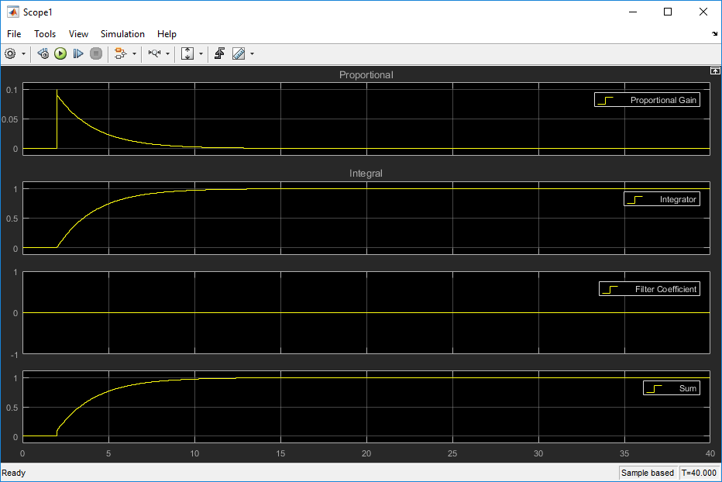
Above: P=0.1 Minimal overshoot, no oscillation

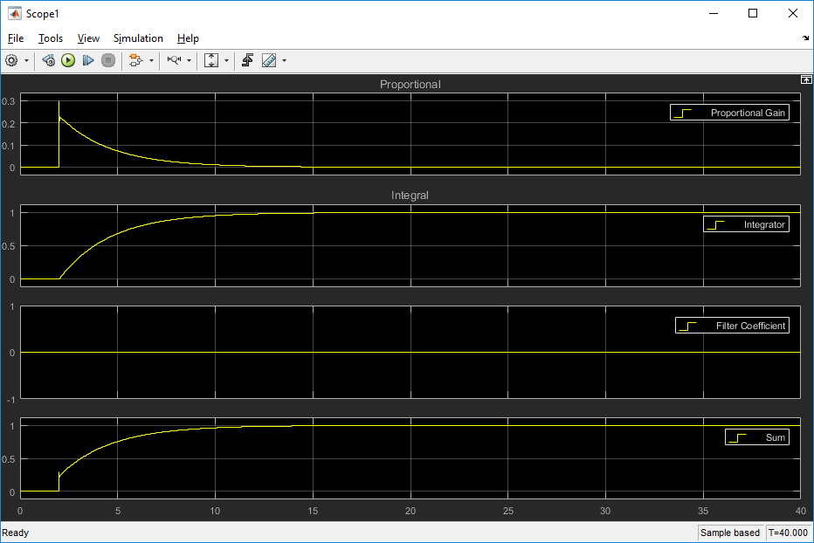
Above: P = 0.3 More overshoot, still no oscillation
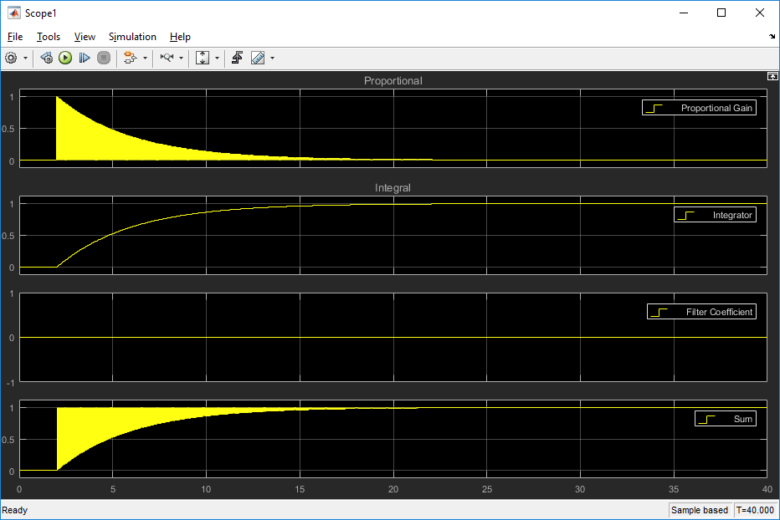
Above: P=1.0 I=0.5 Note oscillation -- at what point between P=0.3 and 1.0 does it start?

Try other combinations of P and I.

This simple model assumes that the position is proportional to the PID output. In practice, we need an integrator to take us from PID output, which should be proportional to velocity, to position. I'll work up a better example to show this.

